**Chapter 4 : Design**

* Introduction
* Architecture and Components Diagram.
* Class Diagram : With Attributes
* Screens Design:
  + Main
  + Specific
* Scholar
* Student
* Admin
* Report Design
* Activity Design

1. **Introduction**

In this chapter, we focus on designing our system based on the analysis given in chapter 4. We will first use a components diagram to visualize how the three systems interrelate. Then we now include the main data – after the ERD - with the class diagrams to show how the complete system is ought to behave. We then Sketch the specific fields that will supplement the analysis to give a general picture of how the application should look like.

A sketches include the main screens shared between scholars and Students, and the remaining screens that will serve all the ideas presented in Chapter 4 and this chapter.

1. **Architectural Design.**

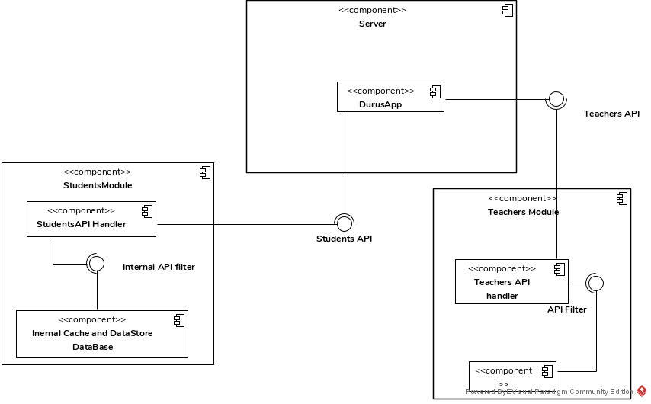

The architectural of the system contains a backend and a frontend. The frontend fetches data from the database wrapped in an API. The API will centralize data and dynamically give data to future modules built on top of the system, i.e. web Application. The API data is fetched and filtered to supply all the screens and populate data in the oncoming screens.

The internal API filter is responsible for handling the different endpoints and making subsequent calls to fetch and receive data. This involves necessary headers and request, security layers and data store in the internal system – caching the responses as well as saving it to local storages in the specific modules.

1. **Design Screens.**

**Typography**

|  |  |  |  |  |
| --- | --- | --- | --- | --- |
| No | **Attribute** | **Font** | **Color** | |
| 1. | Titles | Tajawal - Bold | #204050 | Blue – Dark |
| 2. | Primary Texts | Tajawal - normal | #DEE2E4 | Blue - Faded |
| 3. | Secondary Texts | Tajawal - medium | #204050 | Blue – Dark |
| 4. | Dialogs | - | #FFFFFF | White |
| 5. | Dialog texts | Tajawal Normal | #000000 | Black |
| 6. | Buttons | - | #FAFAFA | White - Light |
| 7. | Selected background | - | #F4D346 | Gold |
| 8. | Unselected background | - | #FFFFFF | White |
| 9. | Hint texts | Tajawal - Light | #707070 | Gray |

**Registration**

Throughout the application, we aimed to make the application as simple as possible. Asking for much details about the user on registration was not in line with this principle. We therefore broke the registration into three types as described below.

Durus App has three types of users: The Admin, Scholar and a Student – who we will refers to as a user. The Admin will need only an **email** and a **password** to register – This will be done by the backend developer working with DurusApp. A scholar will **only be registered** by the DurusApp **administration**. This is to ensure the integrity of the Scholars’ knowledge by the Administration panel. As for the users, they will freely register from the application on first install.

A student needs to enter the following details: ***Username***, ***phone***, ***password***, ***email***, ***field*** (occupation), ***gender***, ***country*** and ***full names***.

However, the registration will be split into two parts. The initial necessary to keep the user going: **Username**, **phone** and **password**. The remaining details are not necessary and can be kept secret by the user but might be needed by the scholar or the Administration for statistics in specific categories. We therefore ask the user to complete

their details once they are logged in.

**Complete Details**

**Sign Up**

* Full name
* Occupation
* Country
* Gender
* Username
* Password
* Confirm Password
* Phone

Save details

Register

**Login**

All DurusApp user types will login with their **usernames** and **password**. Users will only login once, after which they will be automatically be logged in. Were it not for notifications, favorites, personalized downloads and future security tokens, DurusApp would have been open. As such, we keep the user logged in unless he deliberately logs out. Password forgets have not been catered for in this initial version of DurusApp.

**Log In**

* Username
* Password

Log in

**Landing Screen**

By landing screen, we mean what is meant to appear after a successful login or registration. As expected, most screen designs for the scholars and student will differ.

**Scholar**

A scholars landing screen will **always** contain all the ongoing Courses (Dars) they are currently offering with some details. The screen also will have an option to let the Scholar ***add a new Course***. This will initiate a dialog that will let the scholar fill the details of a course: **Category** the Course fall under, **course type** (Open lectures, Boot camps, Course – timely), **course** **title**, **location**(Mosque/ premise where the Course is ongoing) and a rough **estimation of the duration** of a single lecture. A scholar will be able also to activate or deactivate a Course from his timetable but not completely delete it. This will be included in the terms and conditions for a scholar using the app.

**Student**

A students landing screen will not necessarily be the default main screen. If the student is not subscribed to any Course or is a first time user, then he will land in the Scholars and Lectures Screen. If that’s not the case, the student will land on Favorites and Notifications Screen.

**All Courses**

**+**

* Course Title
* Location
* Number of lessons
* Course Category
* Course Type
* Toggle: Active/inactive

**Scholars and Categories Screen**

This is a screen that’s exclusively appears **only** for the student when they are a first time user, has not yet followed any lectures or Scholars or deliberately navigates to this screen from the navigation menu.

This screen has two tabs: **Scholars** and **Categories** tab. The Scholars tab displays a list of Scholars registered with the app. The scholars are displayed with the following details: **Name**, **specialization**, number of **ongoing courses** and their main **location** and **Icon.** It’s important to note that this tab gives the user an opportunity to **search for the desired scholar** by name by a search bar at the top. A toggle button and a **like** on the scholars’ card details will record if the user wants to receive notifications on that selection. On the other hand, the Categories tab displays a list of the **category name**. Both the two are listings are a strategy to sort the Courses in specific ways, as such they all lead to a list of Courses.

Scholars

Categories

Categories

Scholars

Search Scholar

Category Name

* Scholar Name
* Specialization
* Number of Ongoing Courses
* Icon
* Location
* Like/Follow

**Dars (Courses) Screen**

A course is any type of knowledge presentation. It can be an open lecture, a continuous course or a boot camp to memorize books of Knowledge.

Courses are presented in a sorted format – according to the previous screen – and displayed with minimal details, as mentioned in Landing Screen – Scholars. However a student will have an extra toggle button to **follow** a specific Course.

Courses List

* Course Title
* Location
* {***Scholar***}
* Number of lessons
* Course Category
* Course Type
* Toggle: Active/inactive



**Lessons Screen**

A lesson is a lecture given by a Scholar under a certain course. A lessons screen is shared between a Scholar and a student.

A lesson is **recorded** by a scholar and the application **uploads the file** to the server. The scholar adds the **title** before sending the file. The students thus access the same file and is given an option to **play** it or **download** the file. The student will therefore find a list of recorded lessons to download from.

Course Name/Scholar

Course Name/Scholar

Lesson Title

Record new lesson

Lesson Title

Lesson 4: Gardens of the Pious

**Favorites and Notifications Screen**

This is a screen exclusively for students. To supplement a dashboard, a list of **subscribed** or like courses are displayed. Notifications will also be displayed in the same screen.

User will find their notifications here

Liked Courses/Scholars will be displayed here

Notifications

Favorites

**Admin and Report Sketches**

**Dashboard**

Students

Courses

Fields

Course Type

Country

**Sort By**

Number Of Course

Name

Delete

Edit

Name User Id Lectures Title d

Scholars

*This is a template for most Admin Screens.

Tables from the database are displayed as ‘Views’ with All the Crud Operations.

The Admin can sort the table according to any field: A Course can be sorted in terms of

* Number of Students
* Number of Lessons
* Today’s Lesson.

**Reports**

The reports include

* All Users:
* Students in a particular Course
* Courses in a particular category
* Students Who Liked courses
* Lessons in a particular day

*All Users*

|  |  |  |  |  |
| --- | --- | --- | --- | --- |
| Field | User_id | Name | phone | User_group_id |
|  |  |  |  |  |

|  |  |
| --- | --- |
| Student_name | User_id |
|  |  |

*Students in a Course*

*Courses in a category*

|  |  |  |  |
| --- | --- | --- | --- |
| Course ID | Course name | No. of Lessons | Scholar |
|  |  |  |  |

|  |  |
| --- | --- |
| Student id | User id |
|  |  |

*Students and Liked courses*

*Lessons in a particular day*

|  |  |  |
| --- | --- | --- |
| Lesson Title | Course | Is_Active |
|  |  |  |

1. **Class Diagram – Completed.**

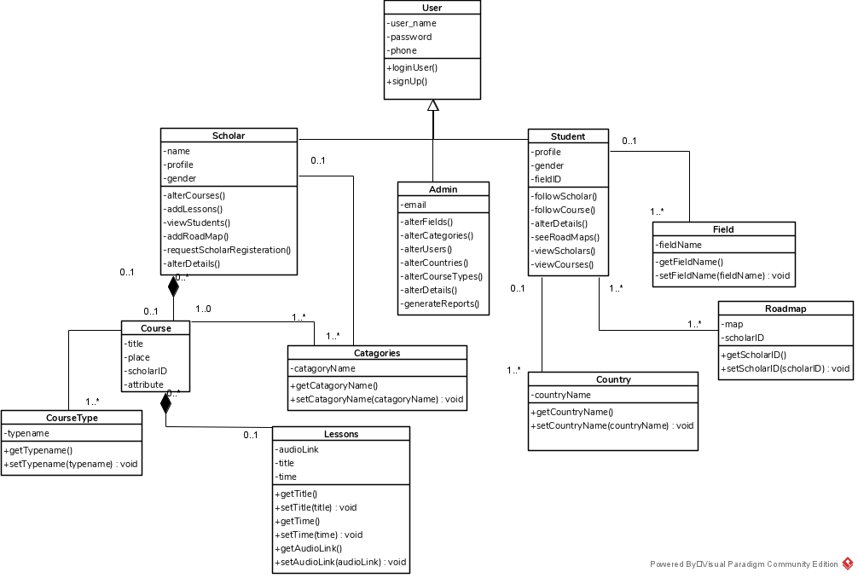

1. **Activity Diagram for Scholars and Student:**

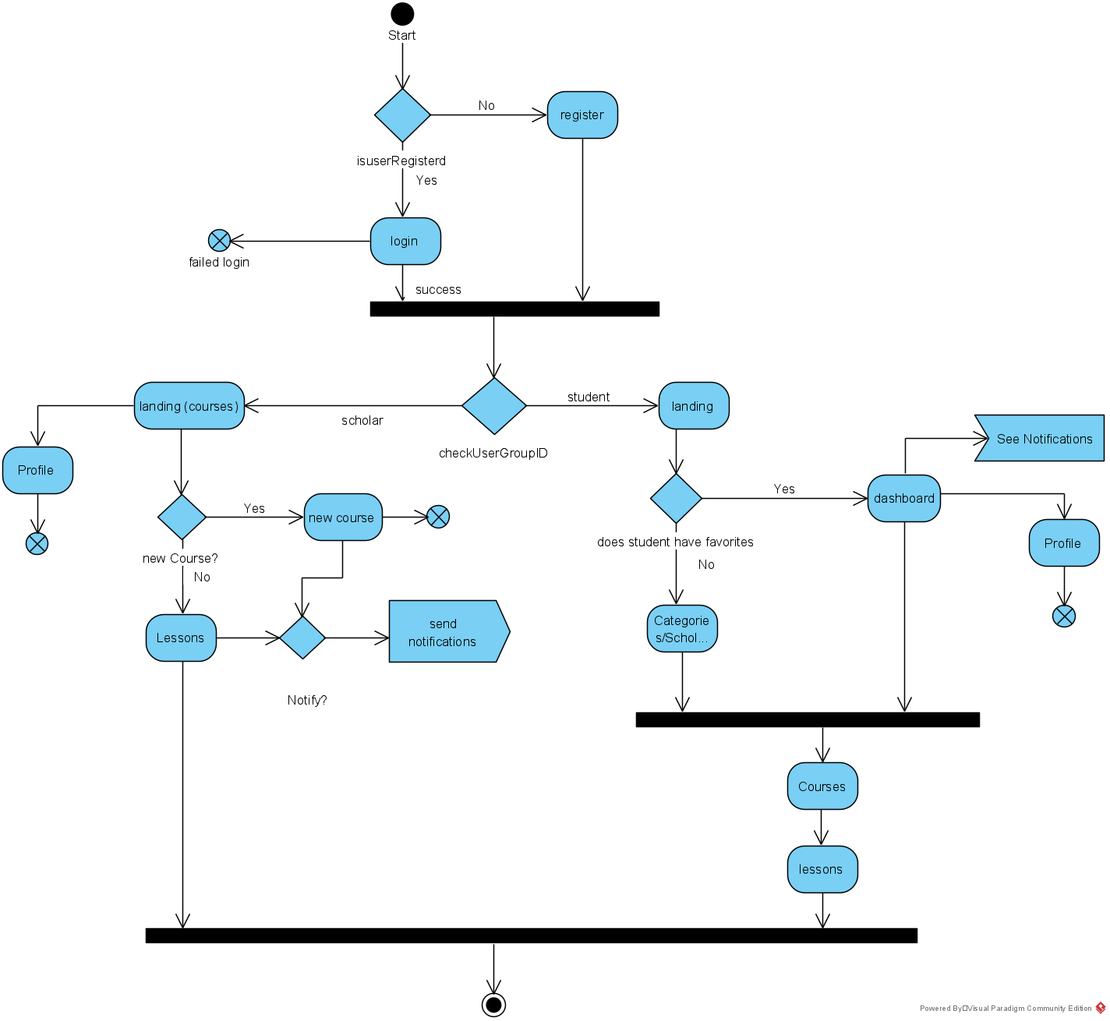

**Admin Activity Flow.**

